July 7th, 2016 | by [Oldrich Siska](http://www.parrotsdailynews.com/author/oldrich-siska/)

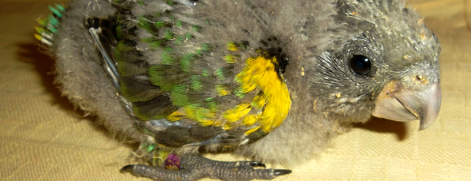

**BREEDING**

**0**

**Read also the second part of this article:**

[**Successful breeding of the Meyer’s Parrot. PART I**](http://www.parrotsdailynews.com/successful-breeding-of-the-meyers-parrot-part-ii/)

.

Today, we recognize six subspecies of the Meyer’s Parrot, these can be classified to two groups depending on their coloration:

**a)green group** – includes subspecies with green belly:

*Poicephalus meyeri meyeri*

*Poicephalus meyeri saturatus*  – intensive yellow coloration on the head

*Poicephalus meyeri reichenowi* – no yellow color on the had and smaller body size

.

**b)blue group** – included species which have a blue belly

*Poicephalus meyeri matschei* – intensive yellow coloration on the head

*Poicephalus meyeri damarensis* – very rare in captivity, no yellow markings on the head

*Poicephalus meyeri transvaalensis* – very rare, yellow band on the had

Unfortunately, hybridizing of the subspecies is very common in captivity. Because of that it might be difficult to determine the subspecies we have. I believe that pure birds are still kept in a few facilities in Netherlands and Germany.

.

[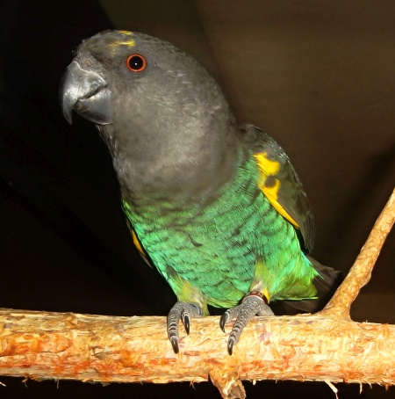](http://www.parrotsdailynews.com/wp-content/uploads/2016/07/mey1.jpg)

Meyer’s Parrot (c) Oldrich Siska

.

The Meyer’s Parrot has never been my „target species“. A breeder who lives not far away from my place was offering two males. One of them was from 2012, in fantastic condition and therefore I decided to buy it. After some time, another friend of mine had a female with similar coloration which was at the same age as my male. Because of that, I could set up a nice pair. The female was sexed by DNA test. Both birds were placed to an inside aviary three meters long with outside flight four meters long. I was really happy about this pair, birds were strong flyers and consumed everything I offered them – seed mix for African parrots, NutriBird pellets, fruits and vegetables, rowanberries, chokeberries and hawthorn berries.

**[READ  Miguel A. Gómez Garza: my most valuable success is the first breeding of Maroon-fronted Parrot in the world](http://www.parrotsdailynews.com/miguel-a-gomez-garza-my-most-valuable-success-is-the-first-breeding-of-maroon-fronted-parrot-in-the-world/" \t "_blank)**

At the beginning of 2015, I saw the pair copulating. This was repeated in following days for several times. I was still thinking that these birds are not old enough to be sexually mature but when I noticed larger belly of the female I decided to hang a conventional vertical nestbox of size 20 x 20 x 35cm with an entrance hole 8cm. The nest was occupied immediatelly by male and a day after also the female came in. At the end of January I found four eggs inside. To put a pair of Aztec Conures in the adjacent aviary was obviously a mistake. I did not expect Meyer’s Parrots to nest so soon and therefore I did not put an invisible partition between the aviaries. Conures are loud parrots and disturbed the young couple on eggs. On February 17th, I found one broken egg, two infertile and one fertile egg which was placed to incubator.

.

[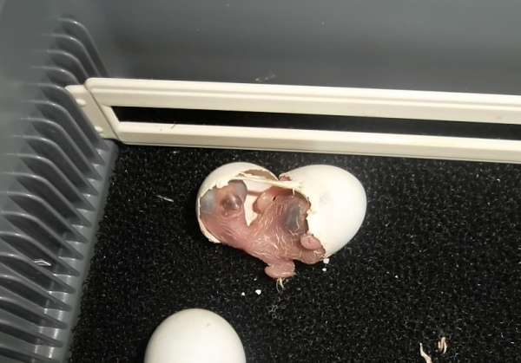](http://www.parrotsdailynews.com/wp-content/uploads/2016/07/chick1.jpg)

Meyer’s Parrot chick hatching (c) Oldrich Siska

[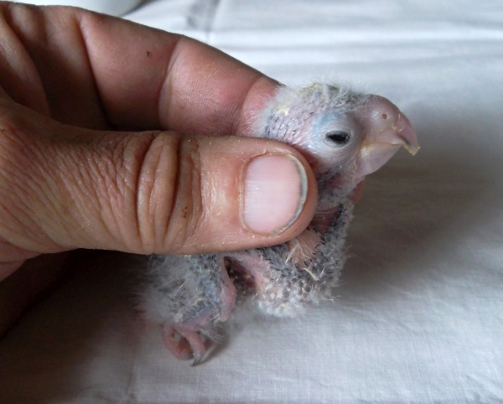](http://www.parrotsdailynews.com/wp-content/uploads/2016/07/chick2.jpg)

Meyer’s Parrot chick (c) Oldrich Siska

.

The cracks appeared on the egg on March 11th. Next day, the chick hatched. You can check frequency of feeding and weight gain in the attached table.

.

**Tab.1  Meyer’s Parrot chick development**

|  |  |  |  |  |  |  |  |  |  |
| --- | --- | --- | --- | --- | --- | --- | --- | --- | --- |
| **Age** | **Day 1** | **Day 5** | **Day 10** | **Day 15** | **Day 21** | **Day 28** | **Day 35** | **Day 42** | **Day 49** |
| **Weight** | 6 g | 11 g | 22 g | 35 g | 64 g | 106 g | 125 g | 134 g | 132 g |
| **Feeding frequency** |  | 3 hod | 4 hod |  |  | 5 hod | 5-6 hod | 6-7 hod | 8 hod |
| **Food amount** | 0.5-1ml | 2-3 ml | 3-4 ml |  |  | 6 ml | 8 ml | 8-10 ml |  |
| **Temperature** | 36,5°C | 36°C | 35°C |  | 33°C | 30°C | 27°C | 24°C | Room temperature |

.

**author: Oldrich Siska**

July 20th, 2016 | by [Oldrich Siska](http://www.parrotsdailynews.com/author/oldrich-siska/)

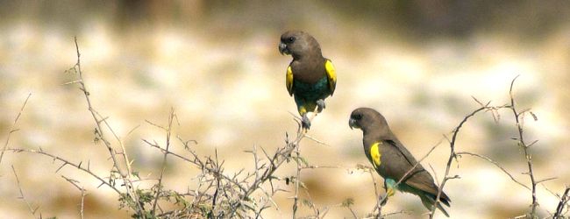

**BREEDING**

**0**

**Read also the first part of this article:**

[**Successful breeding of the Meyer’s Parrot. PART I**](http://www.parrotsdailynews.com/successful-breeding-of-the-meyers-parrot-part-i/)

.

When the chick was 18 years old, I put a ring of size 6,5mm on its leg. It was handfed by formula “Psittacus neonatal” for the first two weeks.  Then I used “Psittacus Energy Handfeeding Formula” (This brand comes from Spanish and the product is designed for feeding of parrot babies in which feather pins have already started emerged and which require higher proportion of fat in their diet – macaws, african parrots, …). Within the first days, formula had more liquid consistency. After some time, I made it thicker but between the third and fourth week of age it seemed that the chick is a little bit dehydrated. Therefore, I used cumin tea. For the whole time, the chick was digesting and growing well. Since the sixth week of age, it started eating soaked seeds, unripe corn, apple, carrot, banana, broccoli and cherries. On 45th day, the baby was put to an inside cage with room temperature.

I have raised a few dozens of *Poicephalus* parrots artificially and therefore I knew that proper socialization with other parrot babies is necessary. Unfortunately, I did not have any other young African parrots so I took a budgie chick from the nestbox and handfed both babies together. At the age of nine weeks, the Meyer’s Parrot was completely weaned and because of that I placed it together with the budgie to outside aviary three meters long. At this moment, it is paired with a male of the same species and age. But he was raised naturally.  Hopefully, the pair will breed some chicks for me in a couple of years. My granddaughter keeps going inside the aviary and plays with the female, the bird never bites (contrary to our handfed Senegal parrots).

**[READ  Breeding of the Yellow-shouldered Amazon. PART II](http://www.parrotsdailynews.com/breeding-of-the-yellow-shouldered-amazon-part-ii/" \t "_blank)**

.  
  
.

At the end of 2015, my breeding pair laid three fertile eggs. However, female left the clutch after 12 days. I found the eggs when they were already cold and I decided to place them to incubator. After a few days, one chick hatched. In the remaining two eggs, embryos died during late phase of development.

In the second half od 2016, five more eggs were laid. Curiously, laying gap between the third and fourth egg and between fourth and fifth egg was four days long. After ten days of incubation, I took them all to incubator. All were fertile, two of them hatched.

.

**Note:**

The breeding pair was set up from two birds of similar coloration and size. Both had the same blue shade on belly and similar distribution of yellow color on the head. The first nesting was successful despite the fact that birds were just two years old. I believe that it is maybe to late to distinguish subspecies of the Meyer’s Parrot in captivity because all have been hybridized in the past. On the other hand, it still makes sense in case of *Poicephalus gulielmi* and *Poicepalus senegalus*.

.

[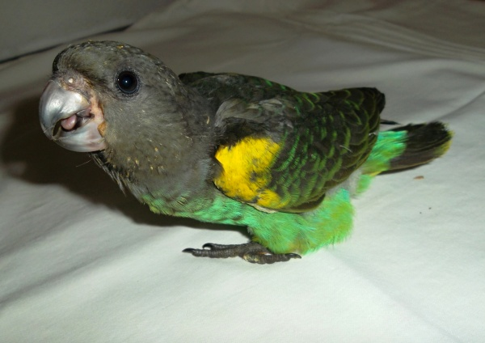](http://www.parrotsdailynews.com/wp-content/uploads/2016/07/meyr.jpg)

Meyer’s Parrot baby 7 weeks old (c) Oldrich Siska

[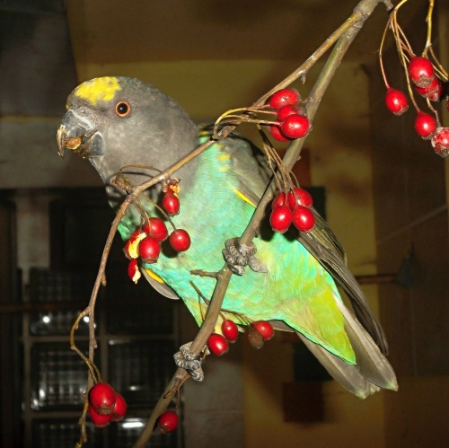](http://www.parrotsdailynews.com/wp-content/uploads/2016/07/meye.jpg)

Meyer’s Parrot breeding female (c) Oldrich Siska

.

As for my experience, we should not keep *Poicephalus* parrots at the same place as South American parrots. This was not the first case in my breeding when*Poicephalus* parrots were disturbed. In the past, I also kept three proven breeding pairs of Senegal Parrots along with Blue-throated Conures and all pairs  failed in that season. They were obviously disturbed and broke their clutches.

**[READ  Breeding of the Rose-fronted Conure. PART II](http://www.parrotsdailynews.com/breeding-of-the-rose-fronted-conure-part-ii/" \t "_blank)**

.

**author: Oldrich Siska**